**TASK 6 – Launching an EC2 Instance using Amazon Web Services**

**AIM :**

Using account in Amazon AWS, create a virtual machine, connect and work with it.

**PROCEDURE :**

**Step 1: Enter the EC2 Dashboard**

1. Open AWS management console in a new browser

https://aws.amazon.com/

1. Find EC2 under Compute and click to open the Amazon EC2 Console.

**Step 2: Create and Configure Your Virtual Machine**

1. You are now in the Amazon EC2 console. Click Launch Instance

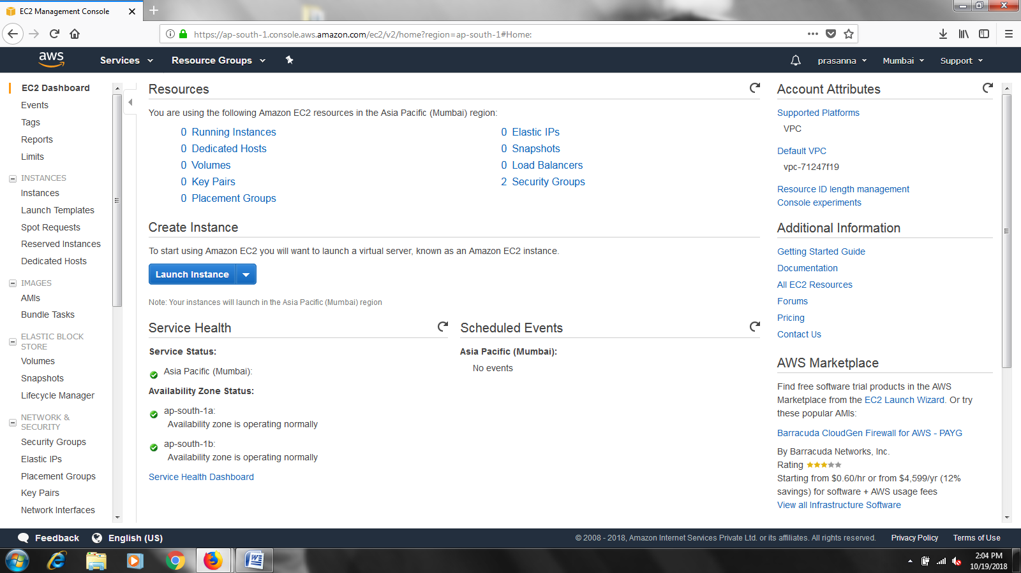

1. With Amazon EC2, you can specify the software and specifications of the instance you want to use. In this screen, you are shown options to choose an Amazon Machine Image(AMI), which is a template that contains the software configuration required to launch your instance.

For this tutorial, find Amazon Linux AMI 2018.03.0 and Click Select.

The dashboard looks as follows :

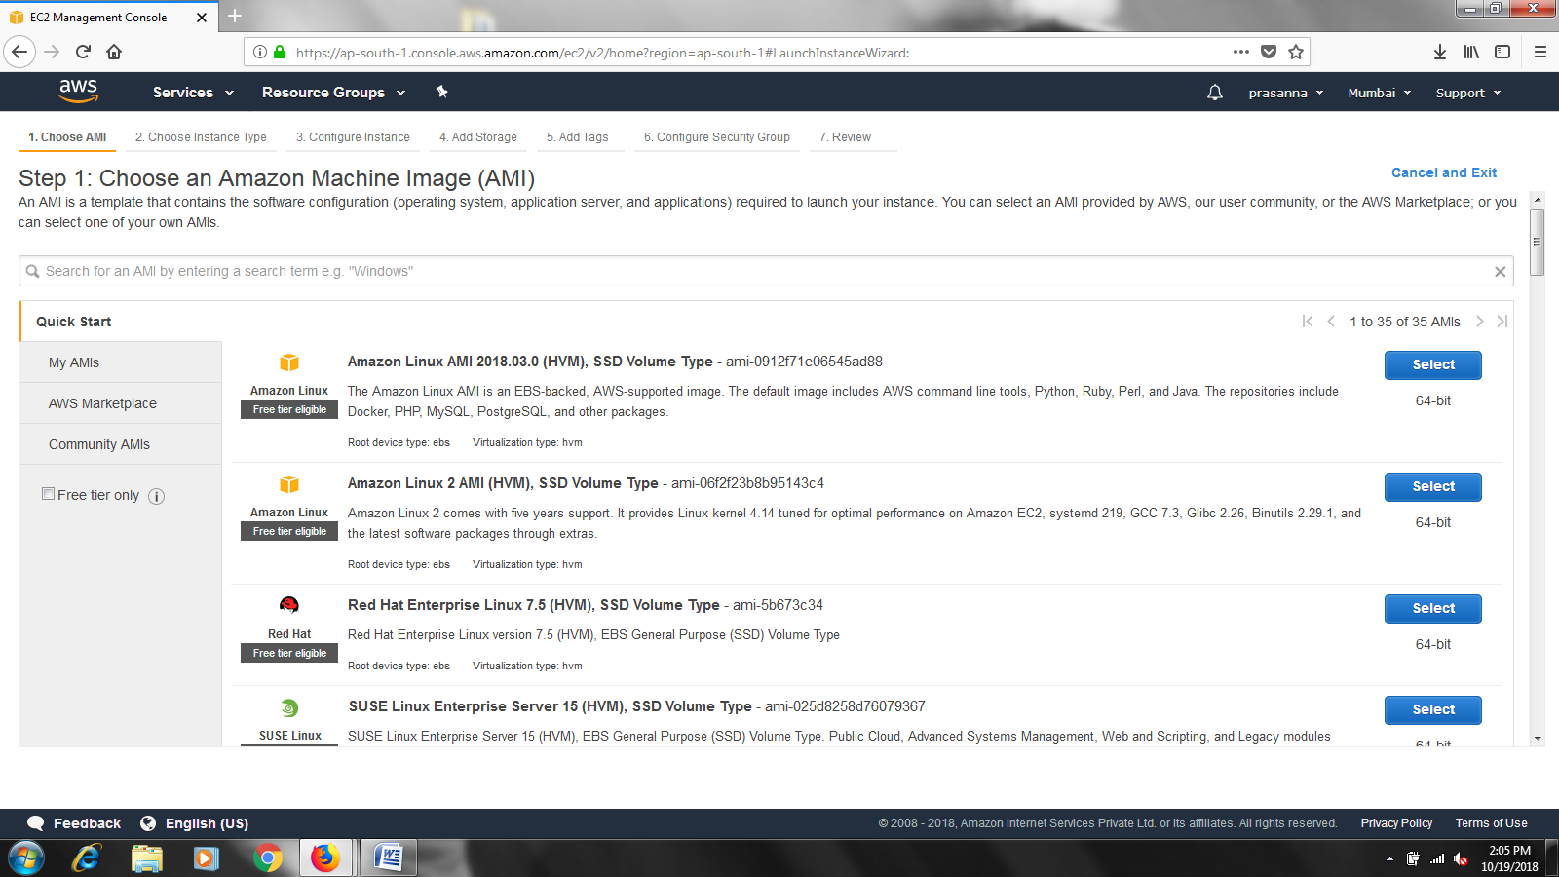

1. You will now choose an instance type. Instance types comprise of varying combinations of CPU, memory, storage and networking capacity so you can choose the appropriate mix for your applications. For more information, see Amazon EC2 Instance Types.

For this tutorial, select the default option of t2.micro-this instance type is covered within the free tier. Click Review and Launch at the bottom of the page.

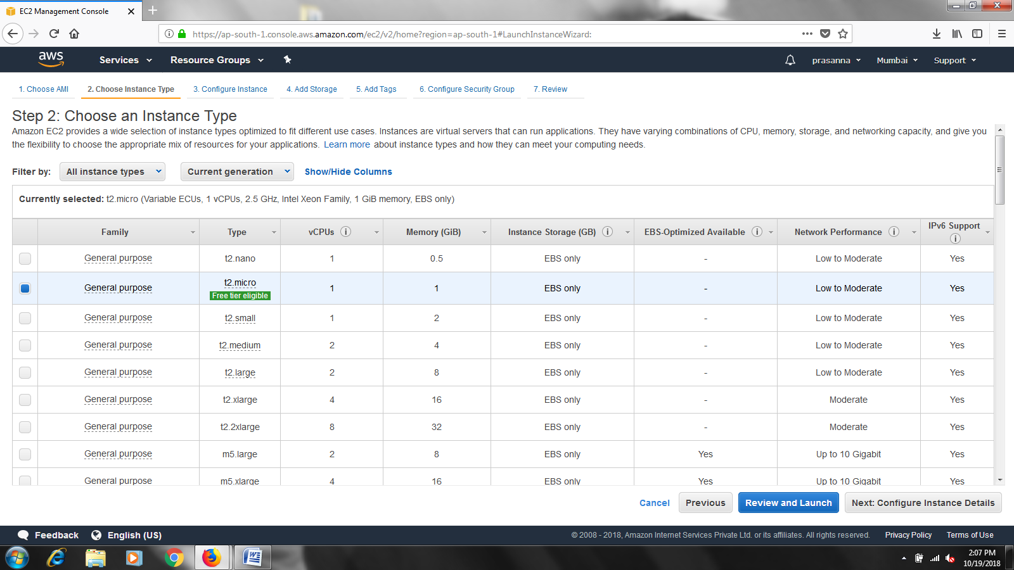

You can review the options that are selected for your instance which include AMI Details, Instance Type, Instance details, Storage, and Tags. You can leave these at the defaults and move next and launch.

**Step 3: Create a security group**

AWS security groups (SGs) are associated with EC2 instances and provide security at the protocol and port access level. Each security group –  working much the same way as a firewall – contains a set of rules that filter traffic coming into and out of an EC2 instance.

Each security group must have a name, allowing you to easily identify it from account menus. It’s always a good idea to choose a descriptive name that will quickly tell you this group’s purpose. In fact, you would be well served to define and use a consistent convention for naming all objects in your AWS account.

Security groups exist within individual VPCs. When you create a new group, make sure that it’s in the same VPC as the resources it’s meant to protect.

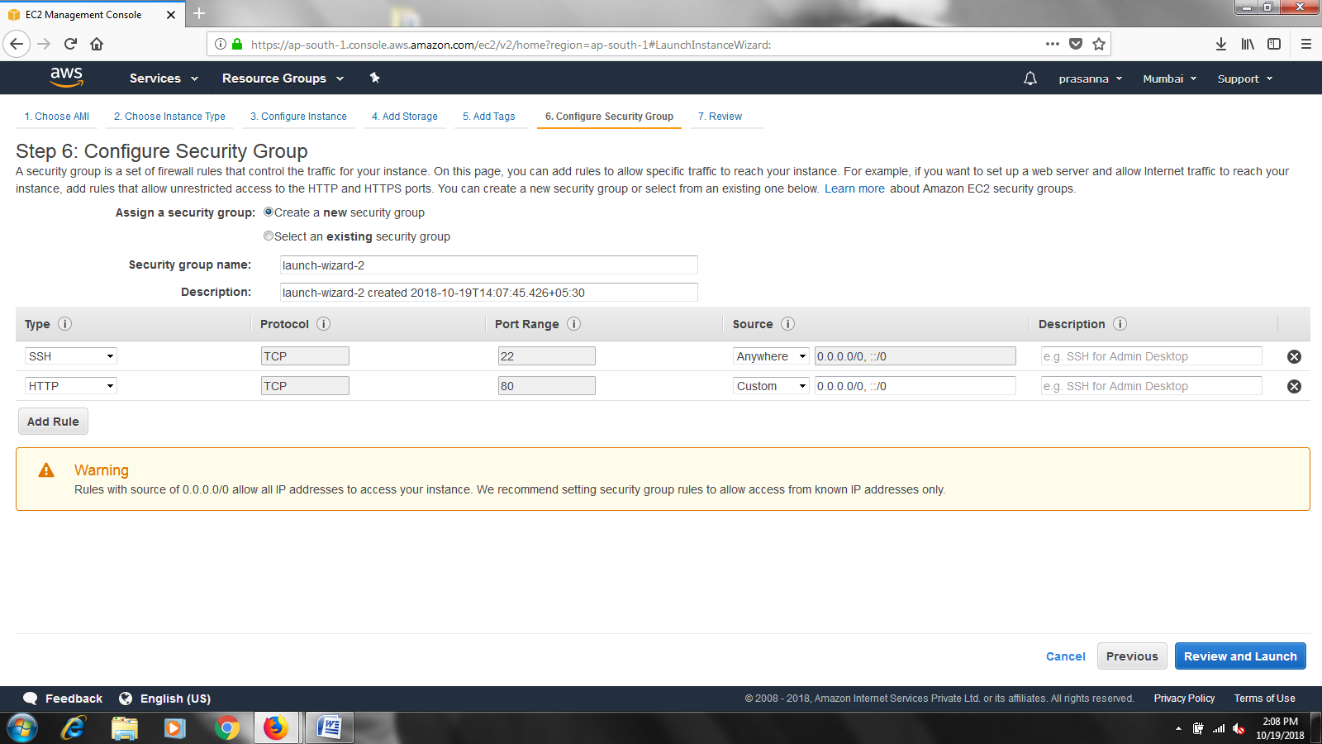

**Step 4: Create a Key Pair and Launch your Instance**

To connect to your virtual machine, you need a key pair. A key pair is used to log into your

Instance (just like your house key is used to enter your home).

1. In the popover, select Create a new key pair and name it Demo. Then click Download Key Pair. Demo.pem will be downloaded to your computer—make sure to save this key pair in a safe location on your computer.

* Windows Users: We recommend saving key pair in your user directory in a sub directory called .ssh (ex.C:\use5r\{yourusername}\.ssh\Demo.pem).
* Mac/Linux users: We recommended saving your key pair in the .ssh sub-directory from your home directory(ex.~/.ssh/Demo.pem).
* Note: If you don’t remember where you store your SSH private key (the file you are downloading), you won’t be able to connect to your virtual machine.

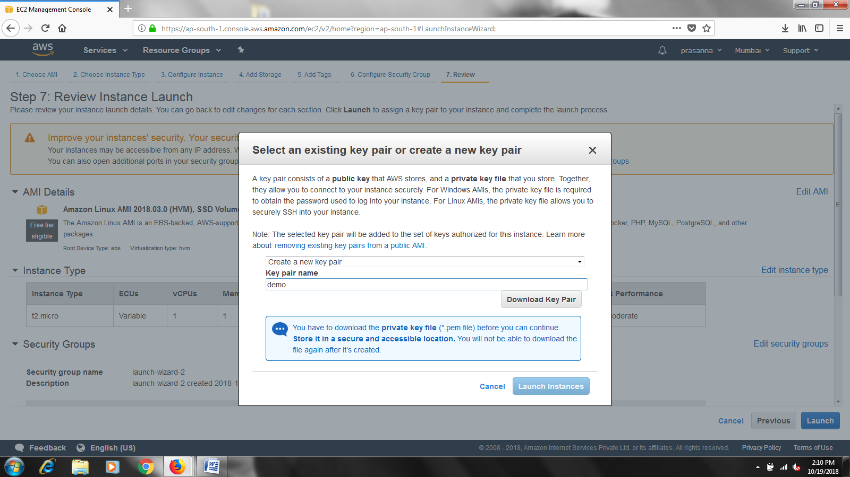

1. After you have downloaded and saved your key pair, click Launch Instance to start your Amazon Linux AMI server instance.

Note: It can take a few minutes to launch your instance.

1. On the next screen, click View instance to view the instance you have just created and see its status. The screen looks as follow after launching the instance.

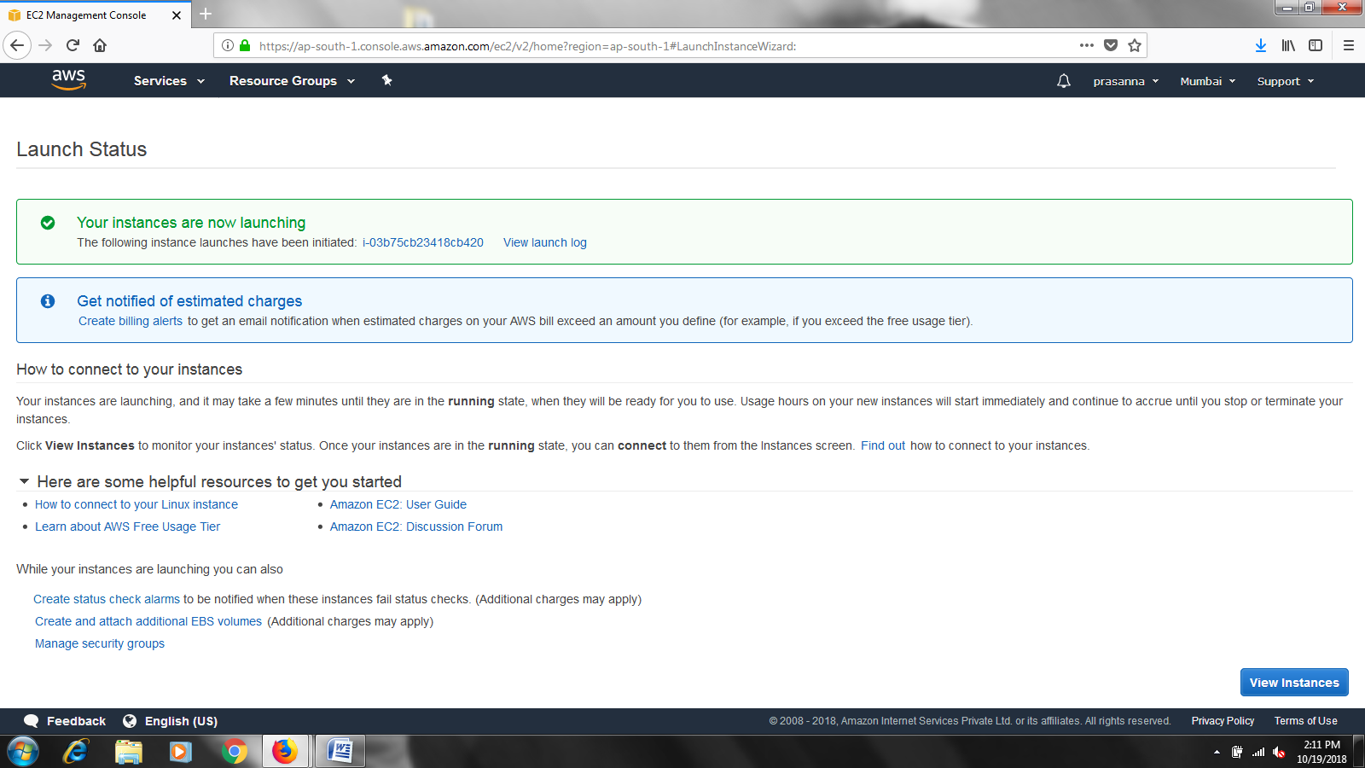

After clicking at the instance we can see the Instance state as Pending , After some time the state changes to Running state where we can start connecting our instance using Putty .

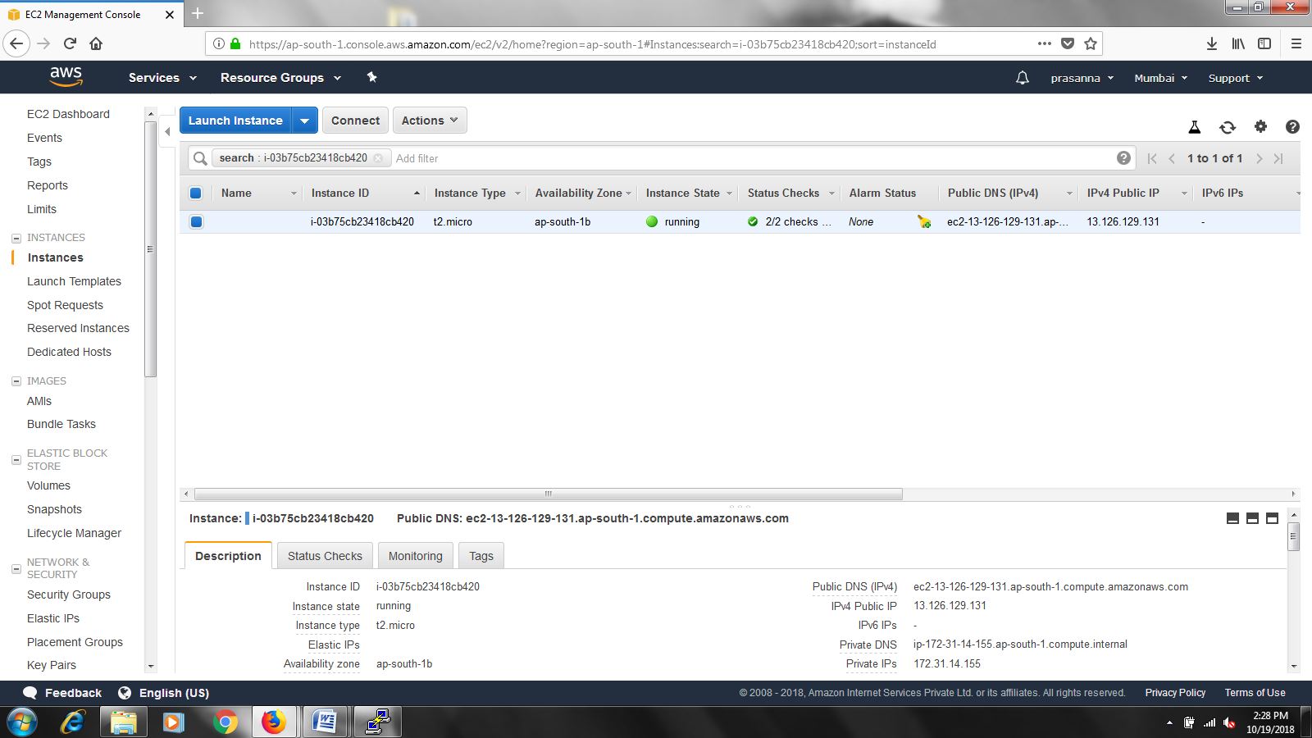

Before connecting to Putty first we need to convert .pem file into .ppk file using the below process

Open **Putttygen - > Click File** **- >** **Click Load private key** which is as follows:

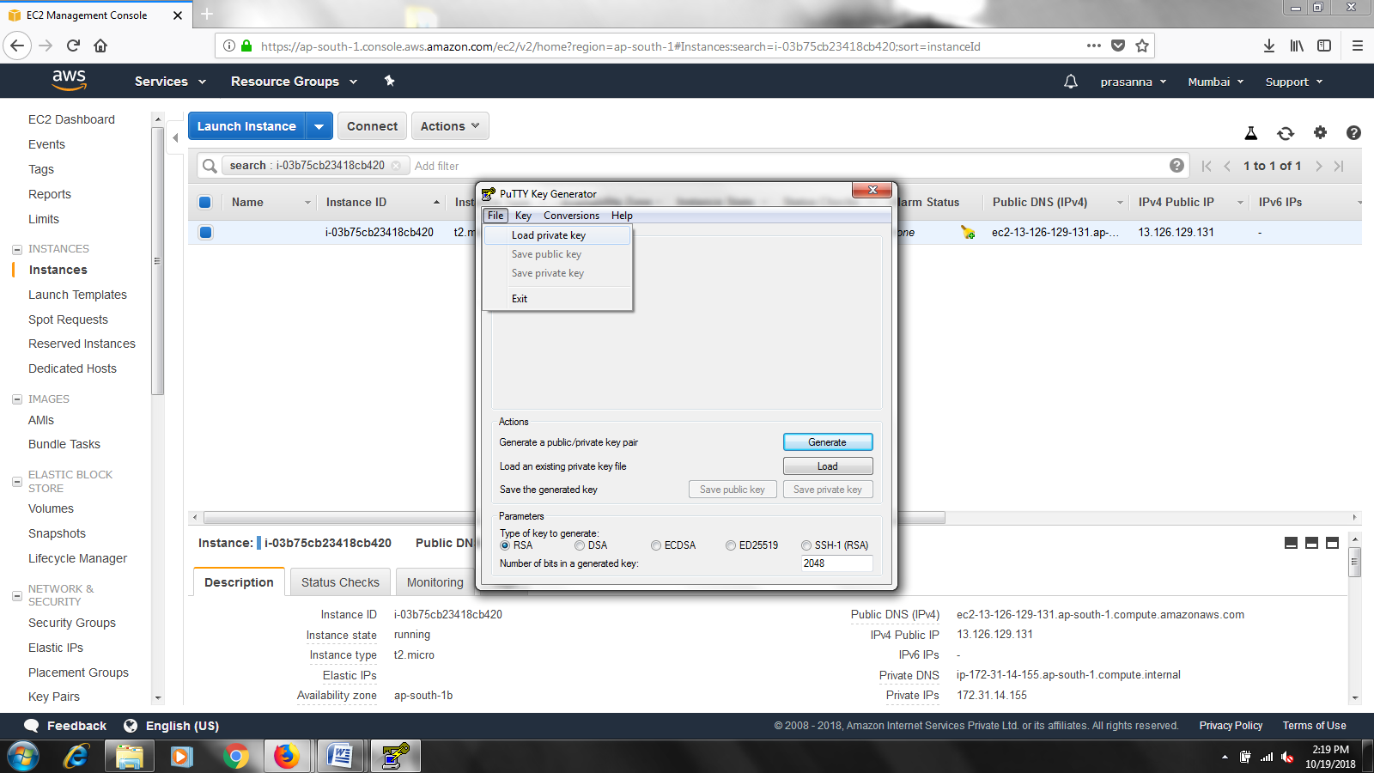

After loading the file it looks as follows. After loading click on Save Private Key.

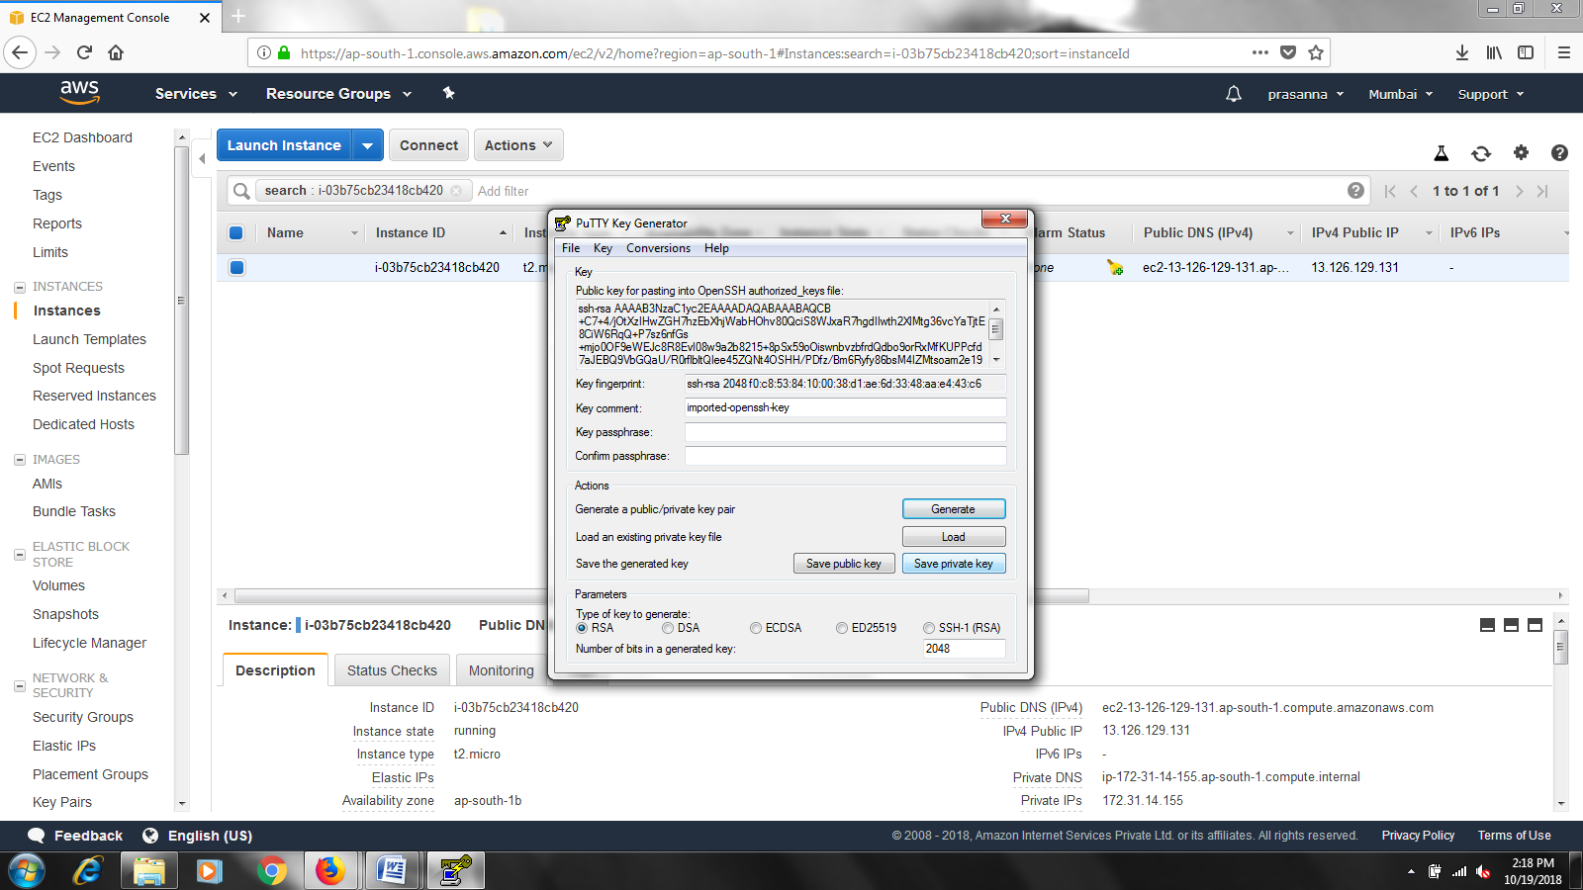

**Step 5: Connect to Your Instance**

After launching your instance, it’s time to connect to it using an SSH client using putty.

1. In order to connect to your Amazon virtual machine instance, you will need to use Host name or public IP of the current running Instance. You can find the public IP of the running instance in the description section of AWS Console.

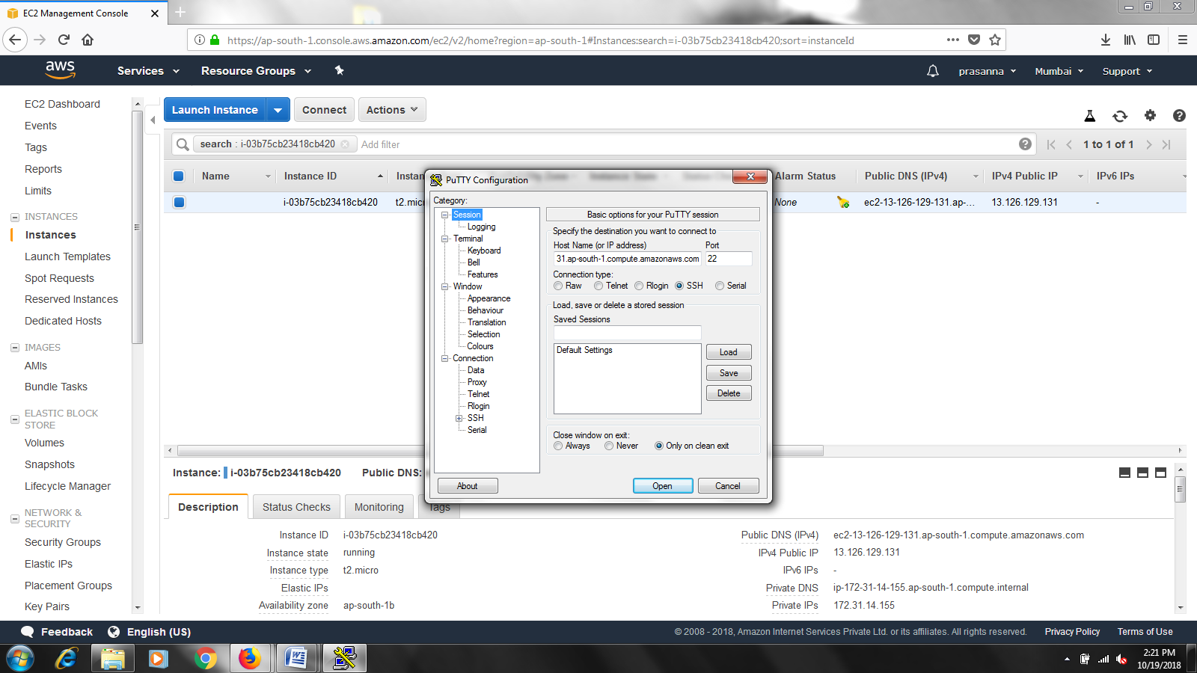

**Step 7:Connect to your Instance.**

. Now inorder to connect to Amazon Linux AMI Server we need to proceed to putty’s connection option **->** **SSH ->** **auth**. Now we need to specify the path of Private Key file(i.e., Demo.ppk file) for Authentication.

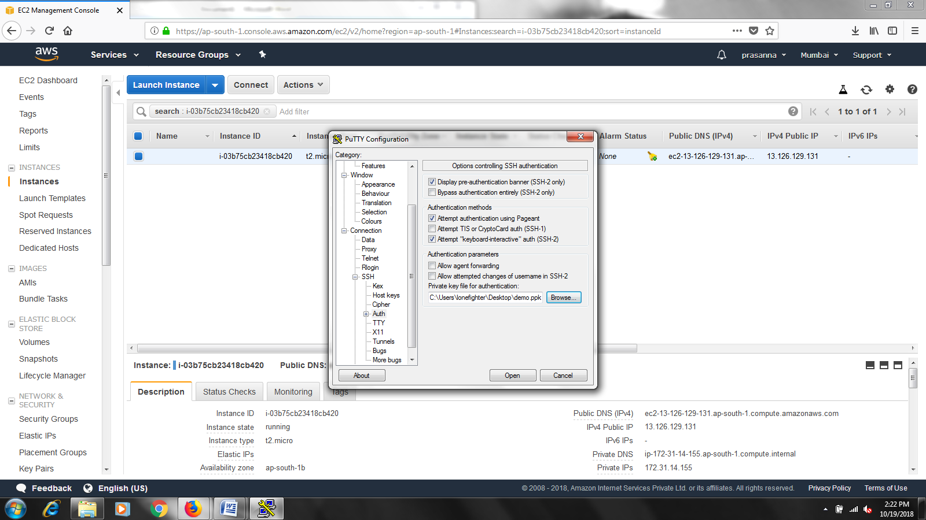

We need to give the username the default user name to connect to Amazon Linux AMI Server is login as : **ec2 -user**

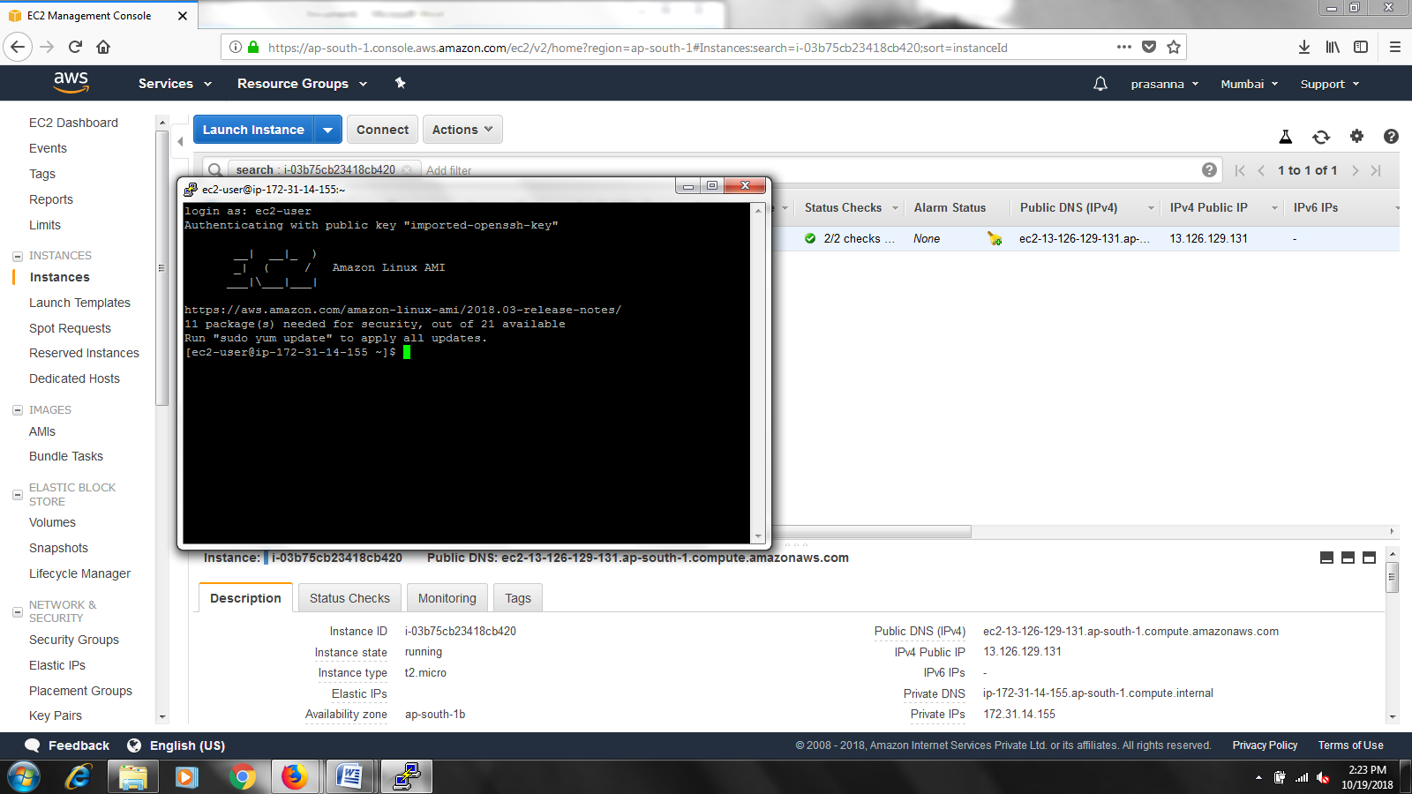

**Step 8: Working with a Current Instance**

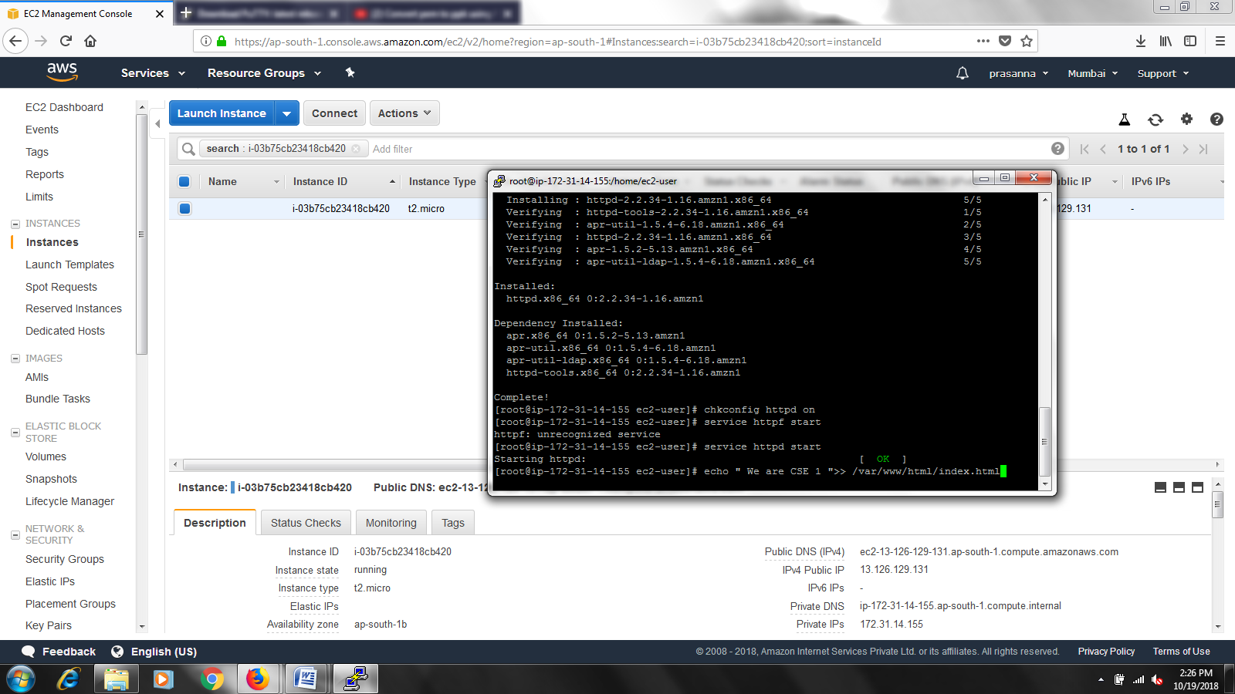

* Here we are trying to make use of the virtual machine instance that is created on AWS
* For our for our experiment we are creating a simple web server on ec2 instance and dumping simple HTML files into that
* Inorder to create the web server the commands required are:

**sudo su** is to convert the permission to root.

**yum install –y httpd** for webserver creation.

**chkconfig httpd on** to check whether the service is on or not.

**service httpd start** to check if server is on then start the server.

* Now create simple HTML file called index.HTML and home.HTML using simple echo commands

**echo “We are CSE 1”>> /var/www /html/index.html**

Now change the directory to html and verify.

**cd /var/www/html** – change the directory

**ls** – to list the files.

**Step 9 : Viewing the output on a www**

Inorder to check the output, open a web browser and type the specified URL: public dns of the launched instance has to be copied from AWS Console and paste it as URL.

The output is as follows :

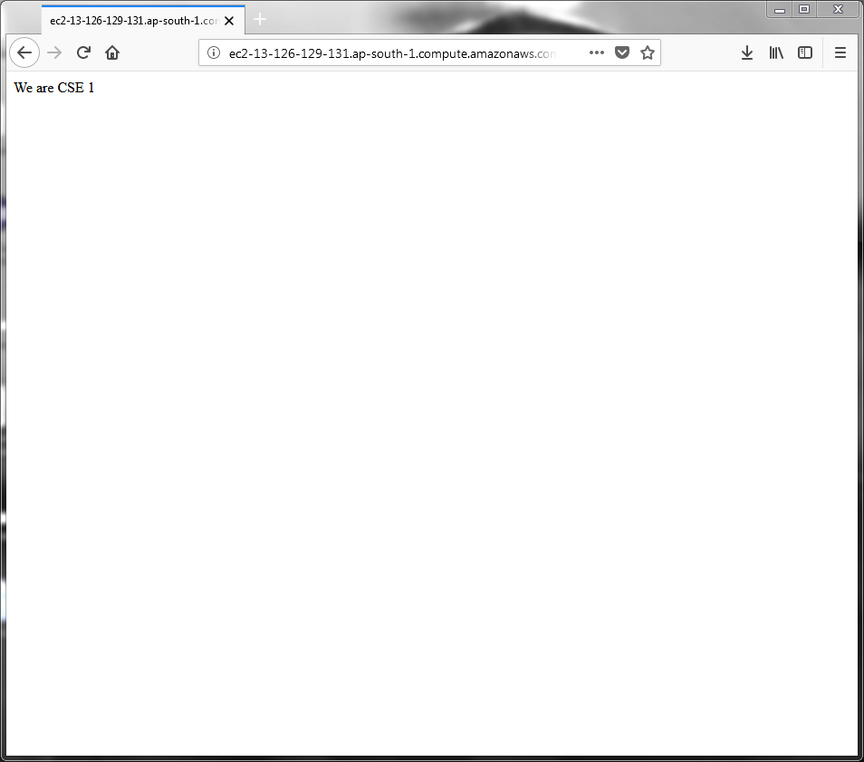

**Step 10: Terminate Your Amazon Linux VM**

You can easily terminate the Linux Server VM from the Amazon EC2 console. In fact, it is a best practice to terminate instances you are no longer using so you don’t keep getting charged for them

1. Back on EC2 Console, select the box next to the instance you created. Then click the Action button, navigate to Instance State, and click Terminate.
2. You will be asked to confirm your termination- select Yes, Terminate.

Note: This process can take several seconds to complete. Once your instance has been terminated, the Instance State will change to terminated on your EC2 Console.

**RESULT** : You have successfully created, configured, and connected to your first Amazon Linux Virtual Machine in the cloud with Amazon EC2.